 | CHAROTAR UNIVERSITY OF SCIENCE & TECHNOLOGY  DEVANG PATEL INSTITUTE OF ADVANCE TECHNOLOGY AND RESEARCH | 

Weekly Report-1

Student ID:23DCS134 | Student Name:Venisha Thakker
From Date:12/05/2025 | To Date:16/05/2025
Semester:4th | Internship ID:

Work done in last week (Attach supporting Documents):

- Planned the scope and features of the Cab Booking System.
- Set up backend using Node.js and Express.
- Created MongoDB database schema for users, drivers, and admin.
- Implemented registration for three roles: User, Drivers, and Admin.
- Implemented secure JWT-based authentication with role assignment.
- Developed Register/Login APIs with proper validations and tested them via Postman

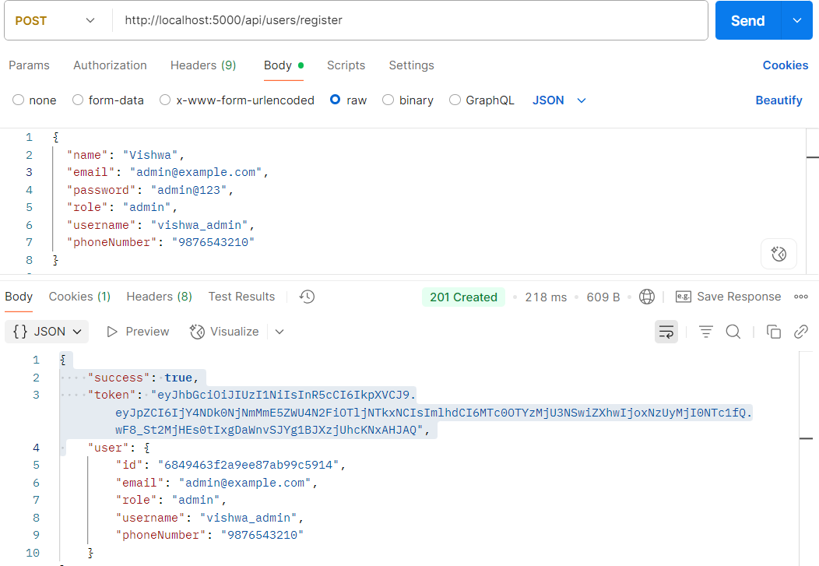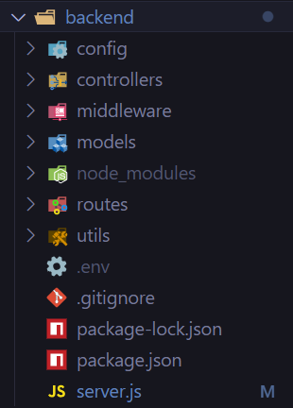

Plans for next week:

- Build and design separate dashboards for each role.
- Create protected frontend routes using React Router.
- Start frontend implementation of login and register pages

References:

- Node.js official documentation – https://nodejs.org
- MongoDB documentation – https://www.mongodb.com/docs
- JWT Auth Guide - https://jwt.io/introduction

Signature of External Guide Signature of Internal Guide

